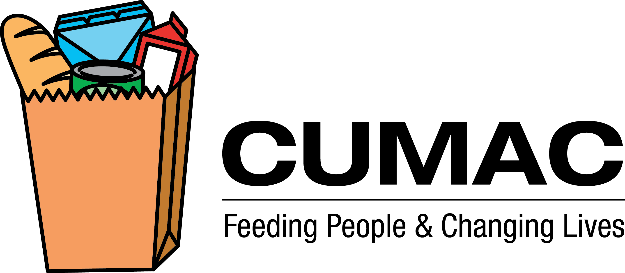
OUR REGULAR FOOD PANTRY NEEDS
As the largest food distribution program in Passaic County, we feed over 2600 low-income children, seniors and adults each month, and share resources with over 50 other feeding programs. We always welcome donations of food, and offer this list as a guideline of frequently needed items:

- Cereal – hot and cold
- Breakfast bars, protein bars
- Powdered, canned and evaporated milk
- Canned vegetables and soups (regular and low-sodium)
- Baby food and formula
- Canned fruit (regular and low-sugar)
- Dry beans, rice, pasta, packaged soup mix
- Canned meals (chili, spaghetti, hash, stew, etc.)
- Canned meats (tuna, chicken, Spam, etc.)
- Taco dinner boxes
- Peanut Butter and Jelly
- Raisins, other dried fruit
- Canned drinks, juice boxes, powdered drink mixes, coffee, tea, cocoa
- Snacks, crackers, cookies
- Protein supplement drinks (i.e. Ensure)
- Spices (salt, pepper, garlic, etc.)
- Condiments (mayonnaise, mustard, ketchup, salad dressing, gravy, etc.)
- Cake and muffin mixes

*We are usually low on the starred items as they are in high demand.
Cans and plastic containers are preferred to glass for storage reasons. We also welcome refrigerated and/or frozen food, fruits and vegetables and bread products that are still fresh as CUMAC has refrigeration units available for storage before distribution.
Monetary contributions are also greatly appreciated. We are able to purchase food at bulk rates through various vendors or at the Community FoodBank of New Jersey for a nominal handling charge. Therefore, we are able to turn even a small cash donation into significant services for our clients. Checks may be made payable to CUMAC and all donations are tax-deductible.
We are always in need of paper and plastic bags to distribute food to our clients. We also collect the pull-tabs from aluminum cans to recycle for cash to turn into food.
If you are dropping off your donations to our warehouse, please call ahead of time so we know to expect you as our hours do vary. If you would like us to pick up the food, please call the office to make arrangements in advance.

Thank you for your support!

CUMAC • P.O. Box 2721 • Paterson, NJ 07509-2721

Phone: (973) 742-5518 • Fax: (973) 742-8115 • info@cumacecho.org • www.cumacecho.org

